Fall 2015

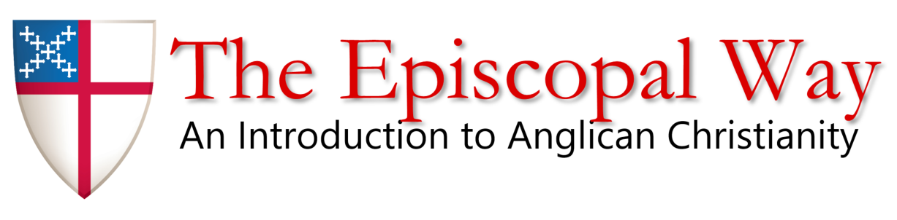

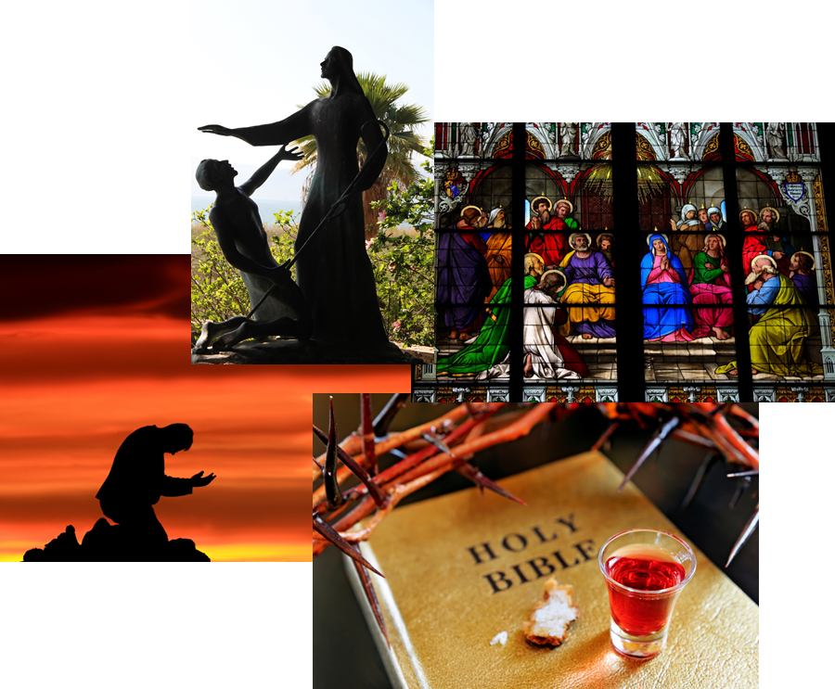

Prepared by Bill Zettinger and Canon Chris Harris

[charris@stbartschurch.org](mailto:charris@stbartschurch.org)

[wzettinger@stbartschurch.org](mailto:wzettinger@stbartschurch.org)

**The Course**

The purpose of this 10 week course, “The Episcopal Way,” is twofold.

***First***; to introduce those who are interested in learning more about our traditions, history, our understanding of scripture, our theology and how we as Episcopalians live out our faith on a day to day basis in both the church and in the world.

**Second**: To prepare those wishing to be confirmed by Bp Mathes in December.

What is confirmation?

Confirmation (BCP 860) is the Rite in which we express a mature commitment to Christ and receive strength from the holy spirit through prayer and the laying on of hands: by the bishop.

It is required by the canons of the church that those to be confirmed have been baptized, are sufficiently instructed in the Christian faith, are penitent of their sins and are ready to affirm their confession of Jesus Christ as savior and Lord.

Yes, first you must be baptized. If you want to be baptized see Mark, Chris or me.

**Who we are and what we will explore!**

As Episcopalians, we are followers of Jesus Christ, our Lord, and we believe in the Father, Son, and Holy Spirit.

The Episcopal Church has members in the United States and the territory of Puerto Rico; and also in Colombia, the Dominican Republic, Ecuador, Venezuela, Curacao, Austria, Belgium, France, Germany, Italy, Switzerland, Haiti, Honduras, Micronesia, Taiwan, and the Virgin Islands.

So, we are not the Episcopal Church of the United States!

* We strive to love our neighbors as ourselves and respect the dignity of every person.
* The Episcopal Church is part of the worldwide Anglican Communion, and traces its heritage to the beginnings of Christianity.
* Our liturgy retains ancient structure and traditions and is celebrated in many languages.
* Both men and women, including those who are married, are eligible for ordination as deacons, priests and bishops.
* We believe in amendment of life, the forgiveness of sin, and life everlasting.
* Lay people exercise a vital role in the governance and ministry of our church.
* We uphold the Bible and worship with the Book of Common Prayer.
* We affirm that committed relationships are lifelong and monogamous. Episcopalians also recognize that there is grace after divorce and do not deny the sacraments to those who have been divorced.
* We affirm that issues such as birth control are matters of personal informed conscience.
* We celebrate our unity in Christ while honoring our differences, always putting the work of love before uniformity of opinion.

**When we meet?**

On the Sundays between the 8:00 and 10:15 services in the Conference room. The actual times will be 9:10 to 10:00 (50 minutes)

**What am I expected to do?**

1. Complete reading assignments when given
2. Participate in class discussion
3. Learn, ask questions and have fun
4. Yes! You can miss a class because handouts will be provided to catch up
5. Handouts provided electronically or in hard copy as needed
6. Provide your contact information!

**What resources do I need?**

1. A Bible, preferably a study bible in NRSV or NIV although any will do
2. A Book of Common Prayer( I will provide one for you if you don’t have one)
3. A three ring binder ( 1”) or more to keep the notes and materials that you will be given

**What will I know when I complete the formation?**

1. *First – there is no final test.* For those attending because they want to be confirmed or received into the church the Bishop may ask you a few basic questions when he meets with you before the laying on of hands. We will be with you when he meets with you – so no worries!
2. A basic understanding of Scripture, how it came into being, how we as Episcopalians understand it and how it speaks to us in our time. You will be able to navigate to any book or letter (epistle) and have a very basic understanding of that book or letter.
3. An understanding Church History before the Reformation of the 15th Century, From the Reformation (15th C) until today and the history of the Anglican and Protestant Episcopal Church of which our church evolved (The Episcopal Church -TEC).
4. You will have an understanding of worship and worship types and be able to navigate the BCP, know what is in it and how to use it in Church and at home.
5. You will have an understanding of the basic teachings and theology of the faith otherwise called the Catechism ( BCP 845)
6. You will have an understanding of the differences and commonality between denominations and a brief introduction to Judaism and Islam
7. You will be well prepared to be confirmed or answer questions of a general nature by those who ask them of you – You will all become scholars in the church!

**The Syllabus – 10 Sessions Plus Graduation Dinner**

* Sunday 13 September – **Orientation – Session1** 
  + What we will learn?
  + Course Overview
  + Material Required
  + Collect Contact Information
* Sunday 20 September – **Bible Part 1- Session 2** 
  + What the word BIBLE really means?
  + How the bible came to be and Bible History/ When written
  + Different Translations and what they men
  + The languages of the bible
  + How we read the bible “ Exegesis”
  + What is Biblical Criticism
  + Navigating the Bible
  + How we understand Scripture in our church
  + The Organization of the Bible
* Sunday 27 September – **Bible Part 2- Session 3** 
  + What’s in the Hebrew Bible
  + Fact or Metaphor
  + When written?
  + Who it was written for?
  + How to read Scripture?
  + The Torah (The Law!)
  + The Prophets (What’s a prophet?)
  + History Books
  + Psalms and Writings
* Sunday 4 – October – *St Francis Sunday ( Blessing of Animals at 10:15)*
* Sunday 11 October - **Bible Studies –Part III – Session 4** 
  + What’s in the New Testament? Why is it New?
  + The Gospels “ the Good News”
  + Who was Jesus?
  + The Epistles of Paul When were they written?
  + Pastoral Epistles
  + Other Epistles
  + Revelation. Does it predicts the Future?
* Sunday 18 October – **Church History Part1 – Session 5** 
  + From Jesus time to the Reformation
  + The persecution and Martyrdom
  + Constantine and the “Battle of Milivan Bridge”
  + The historic Councils and why they are important ‘Ephesus”
* Sunday 25 October - **Church History Part 2 – Session 6** 
  + From the Reformation to today
  + What was the Reformation and why?
  + Who were the reformers?
  + What was Luther’s role?
  + Beginning of Anglicism and Cranmer, Henry VIII and divorce
  + The Elizabethan Settlement? ( Via Media)
* *Sunday 1 Nov – Optional Class Time - All Saints Day - DST Ends (Consecration of The* *Very Rt Rev Michael Curry PB at the National Cathedral on Saturday) ( Harris)*
* Sunday 8 November – **Protestant Episcopal Church in America & Polity – Session 7** 
  + The beginning of the Protestant Episcopal Church
  + The Revolutionary War
  + Slavery
  + The first Bishops
  + Bishops Seabury
  + Church Organization Yesterday and Today
  + How the Church Works
* Sunday 15 November – **BCP & Worship Part 1- Session 8** 
  + How the BCP came to be and why it matters?
  + Navigating the BCP, What’s in it? Where do I find stuff!
  + Anglican Worship
  + Daily Office
  + The lectionary
* Sunday 22 November - **BCP & Worship Part 2- Session 9** 
  + Eucharist’s Rite 1 and Rite 11
  + Pastoral Offices
  + Liturgies on Special Days
  + Episcopal Services
  + Psalms
  + Prayers
  + Other Worship Books – TBOC, Hymnal. Holy Women Holy Men, Enriching our worship
* *Sunday 1st Advent 29 November – OFF No Class*
* Sunday 6 December – **Catechism and Understanding the Faith Part 1- Session 10** 
  + Theology of the faith ( What is Theology?)
  + An Outline of the Faith Catechism ( BCP 845)
  + Human Nature
  + God the Father and the Trinity
  + The Old Covenant
  + The 10 Commandments
  + Sin and redemption
  + God the Son
  + New Covenant
  + The Creeds
* Sunday 13 December – **Catechism and Understanding the Faith Part 2- Session 11** 
  + The Holy Spirit
  + The Blessed Trinity
  + Scripture
  + What is the Church
  + The Ministry
  + Prayer and Worship
  + The sacraments
  + Baptism
  + The Eucharist
  + Other Sacraments
  + What we believe as Episcopalians and why
* **Friday 18 December – Graduation Dinner ( Family invited) Time Place TBD**
* Sunday 20 December – Confirmation at 10:15am

Note: On Days off if the class wants to meet for special sessions – we can?